1. **Step 1: Name your Galaxy History**

You will want to create a new history in Galaxy. Using the “history” feature wisely allows you to keep all of the work on a similar topic/project together. You should give your history a short memorable name (you can do this by clicking on the pencil icon next to “Unnamed history”).

Figure 1. Screenshot of the Galaxy home page.

**Step 2: Identify your phage genome(s) of interest**

You will want to identify the phage genome(s) that you wish to annotate. For each genome, you will need its **NCBI accession number**. (N.B.: At this stage, you will probably find it helpful to begin collating a table of phages with their accession numbers and any other relevant information – you will need this for your materials&methods section of your thesis.)

You may identify phages from the literature (e.g., from genome sequence announcement papers), from browsing the NCBI databases, or from the phagesdb database. For this example, I will choose a phage that infects *Streptomyces coelicolor* A3(2) from phagesdb.

Figure 2. The Actinobacteriophage Database home page (<https://phagesdb.org/>)

I can browse to a phage of interest (click *Streptomyces* in the list on the right 🡪 click on “Click here to view only sequenced phages” 🡪 click on the number of species in the gray bar 🡪 click on your desired species name 🡪 click on the name of your phage of interest.).

Figure 3. PhageDB entry for Streptomyces phage phiC31.

Each database entry will have the **metadata** for your phage of interest (N.B. note down any information relevant to your project/hypothesis in your table at this point.) You will also find (scroll down) the **GenBank Accession** number for your phage of interest (in this case it is AJ006589). Add this number to your table and copy it so that you can enter it into Galaxy.

**Step 3: Import your phage genome data into Galaxy**

Figure 4. The NCBI Accession Download tool in Galaxy.

You will want to use the **NCBI Accession Download** tool in Galaxy to import your phage genome sequence. You can find this by browsing through the “Tools” menu in the left-hand pane (Figure 4), or by searching for it by name.

You can either provide Galaxy with a file containing the accession number(s) you wish to download, or you can use the “Direct Entry” method and paste your accession numbers in directly (Figure 5).

Figure 5. Using the Direct Entry method in the NCBI Accession Download tool.

The defaults should be for Molecule type: nucleotide and file format: FASTA – ensure that these have been correctly selected, and click “Run Tool”.

Figure 6. Pending items in your Galaxy History pane.

The history pane on the right of your screen should show an entry for a log and a list of the downloaded files. These will appear gray initially; orange/peach when the server is working on running the tool; and green when the task has completed. If an error occurs, the boxes will turn red. (N.B. Do not delete items from your history just because they have turned red – the error messages usually provide some helpful information that will help you to troubleshoot your work.)

**Step 4. Annotate your phage genome**

There are many different tools which you could potentially use to annotate your phage genome – in this demo I will be using a tool called pharokka which is available through Galaxy. (You could also use a tool such as Prokka – which you used in BM425 – but pharokka is specialised for bacteriophage genomes and should run a bit faster.)

You can read all about pharokka here:

Bouras, G., Nepal, R., Houtak, G., Psaltis, A. J., Wormald, P.-J., & Vreugde, S. (2022). Pharokka: a fast scalable bacteriophage annotation tool. *Bioinformatics*, *39*(1). https://doi.org/10.1093/bioinformatics/btac776

You can find pharokka in Galaxy by searching for it in the toolbar on the left.

Figure 7. Using pharokka to annotate your phage genome of interest.

You will need to “point” this tool at the genome(s) you have uploaded into Galaxy in Step 3.

Click on the folder icon (Dataset collection) and select the appropriate collection from your history (Figure 7).

Click “Run Tool”.

**Step 5. Examine and analyse your annotated phage genome(s).**

You should have two new items in your history on Galaxy: a GFF and a Genbank file (the annotation of your phage genome in two different formats). You can look at either by clicking on the item and then clicking on the “eye” icon to visualise.

Figure 8. GFF output from pharokka.

Figure 9. Genbank output from pharokka.

You may also find it helpful to visualise your data using e.g. JBrowse.

Find JBrowse in Tools (by searching for/browsing to it), and select the following options:

Use a genome from history

Select the reference genome – Dataset Collection (folder image) – select your genome file (from NCBI Accession Download)

Click “Insert Track Group”

Click “Insert Annotation Track”

Track Type GFF/GFF3/BED Features

(folder image – Dataset collection) – select your pharokka GFF collection

Click “Run Tool”

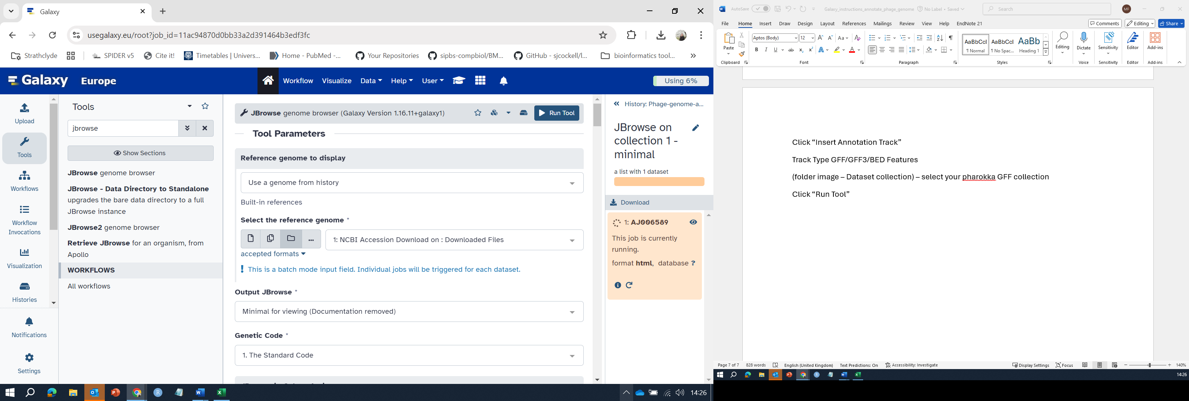

Figure 10. JBrowse options.

To examine your annotated genome in JBrowse, click on the “eye” icon next to the JBrowse item in your history, this should display your genome (you can browse through this using the magnifying buttons and left-right arrows):

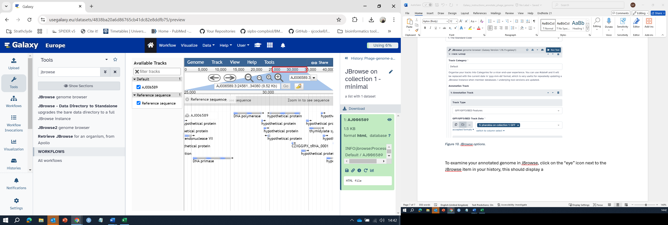

Figure 11. JBrowse visualisation of the phiC31 genomate annotated by pharokka.

Your other downstream analyses of your annotated phage genomes will vary depending on your project/hypotheses (see next tutorials…)